Dr. Zukisani "Dr. Zee" Mxoli Professional Speaker Profile
1. Updated Professional Biography
DrZee BIO:
IMBIZO by DrZee Community Celebrity King • International Public Speaker • Businessman • Moral Regeneration and Leadership Expert
A devoted family man who makes time to Counsel, Coach & Address Professionals, Business Owners, Influential Leaders, Institutions & Communities, on Real Life Issues affecting Men, Women, Youth, Families and People from all walks of life; equipping them with leadership skills. #Africansofinfluence #IMBIZObyDrZee
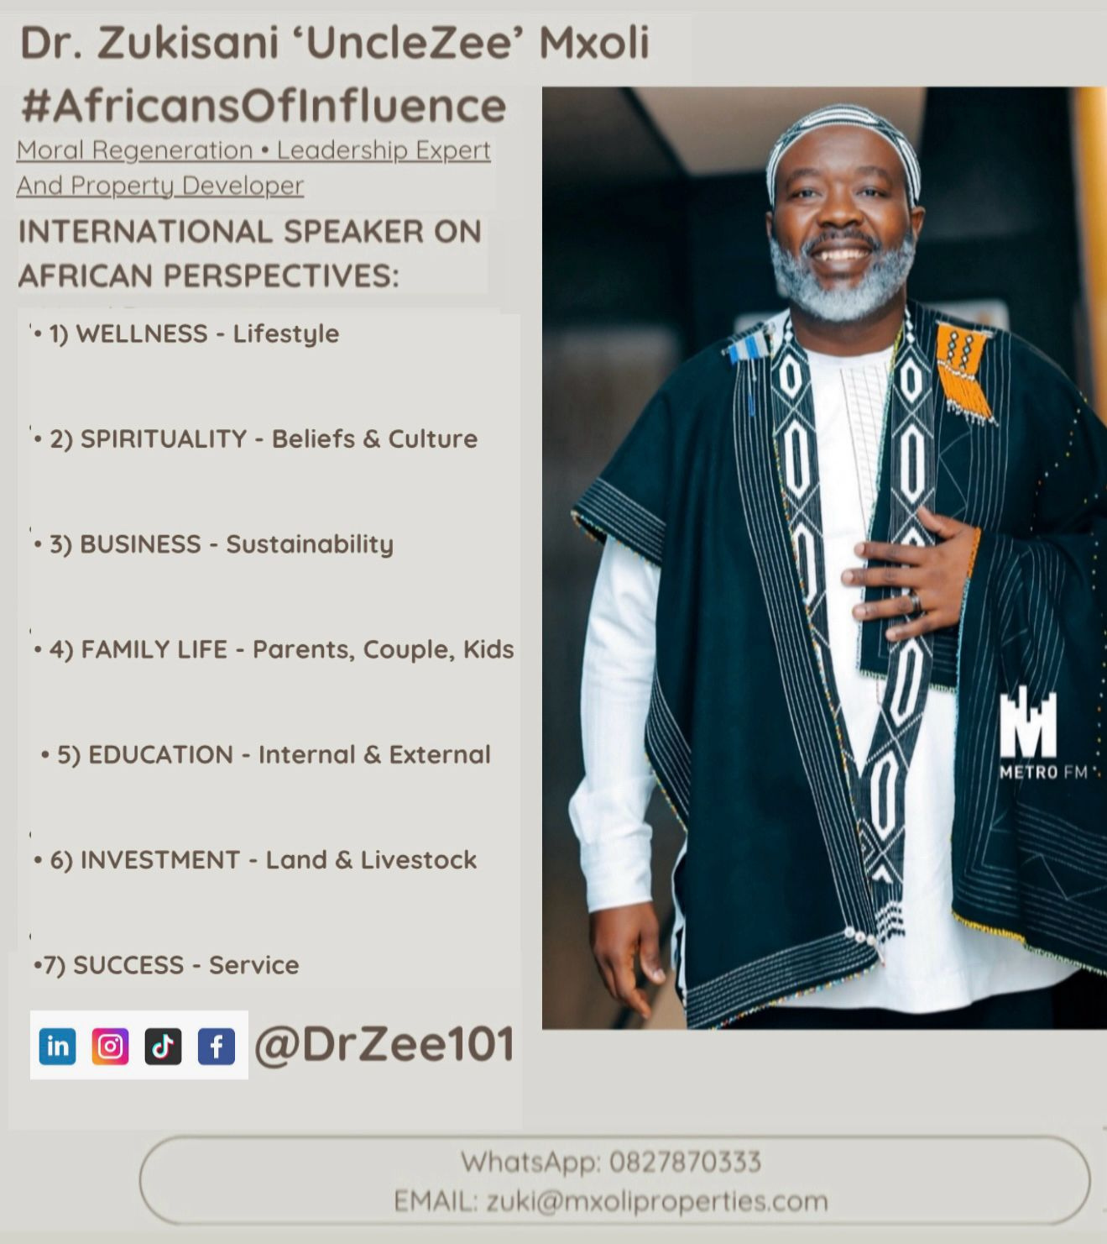

2. High-Resolution Professional Headshots

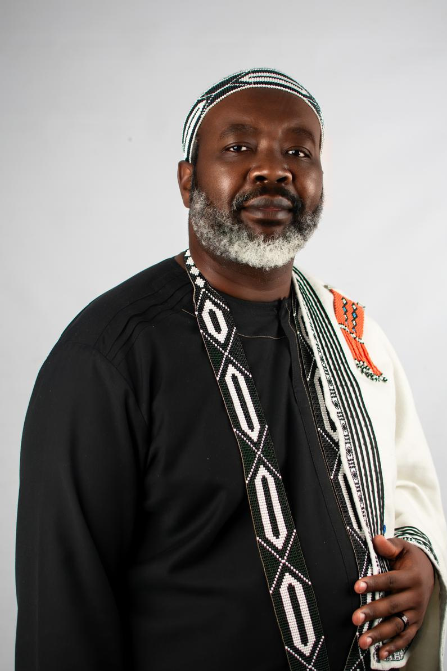
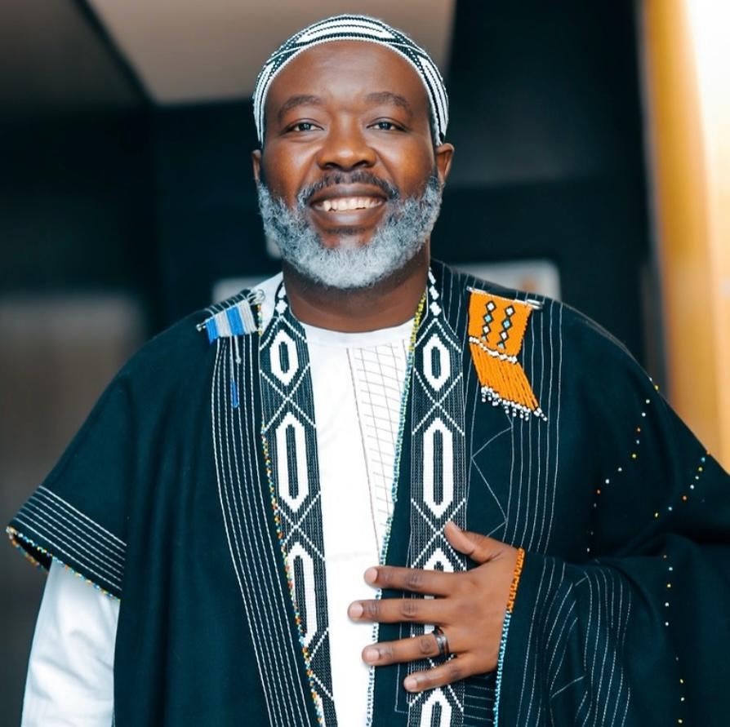

3. Speaker / Company Profile
Speaker Profile and Company Profile attached separately.
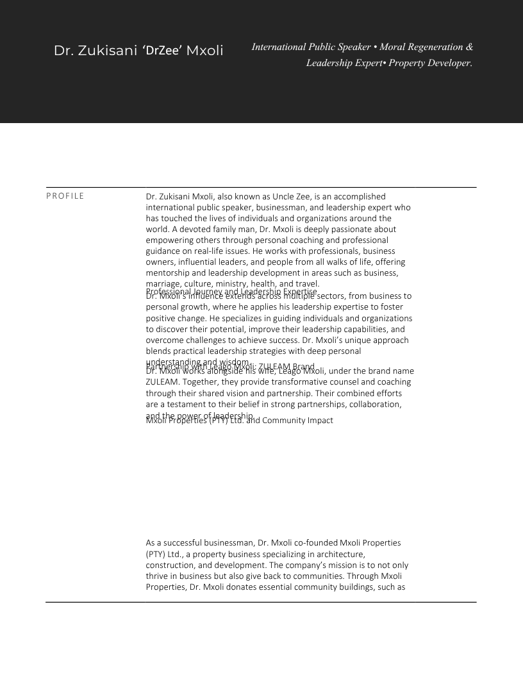
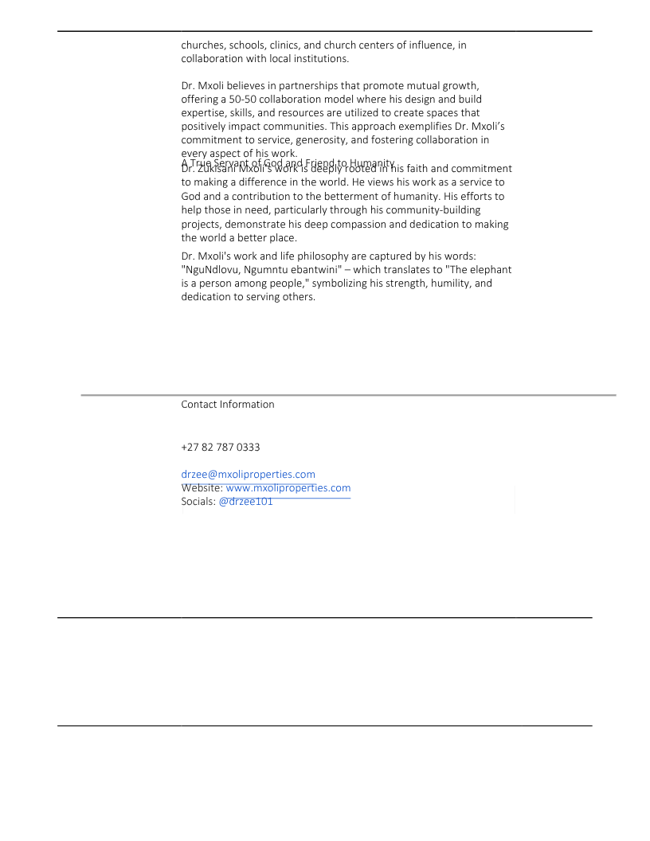

4. Keynote Topics & Speaking Themes
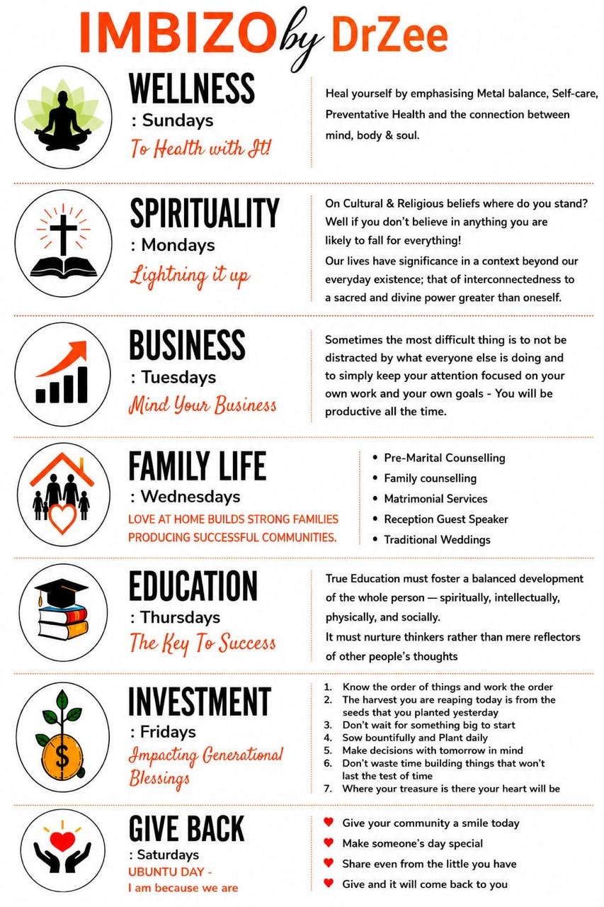
5. Keynote & Masterclass Descriptions
Each keynote and masterclass is tailored to equip audiences with practical leadership skills, entrepreneurship insights, personal development strategies and tools for sustainable community impact.
6. Preferred speaker fee range and flexibility for CSI/pro bono engagements
When it comes to fees I will post what was rated by the company that wanted to run my speaking engagement portfolio although they couldn’t do much as they are in music more than public speaking …
Please note my offering is that I am available for the Speakers Firm full time for any engagements both speaking and MC or program director services - I am happy to speak and would love to serve at all Empowaworx upcoming events either as Speaker or MC at no cost …
I am flexible to any amount that is paid to me even though I have shared the rate cards from the other firm, so I’m flexible …

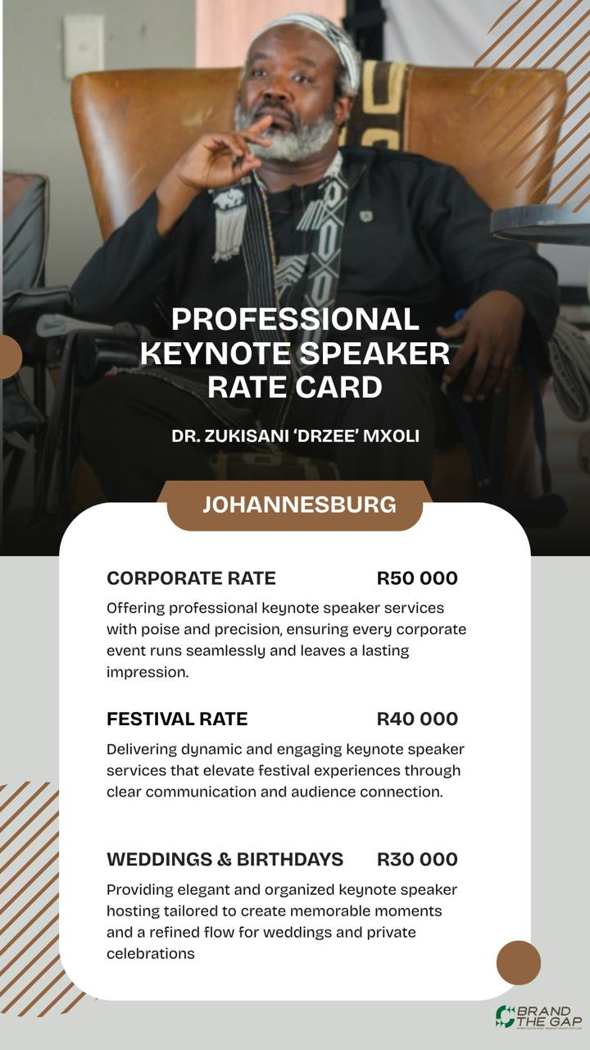

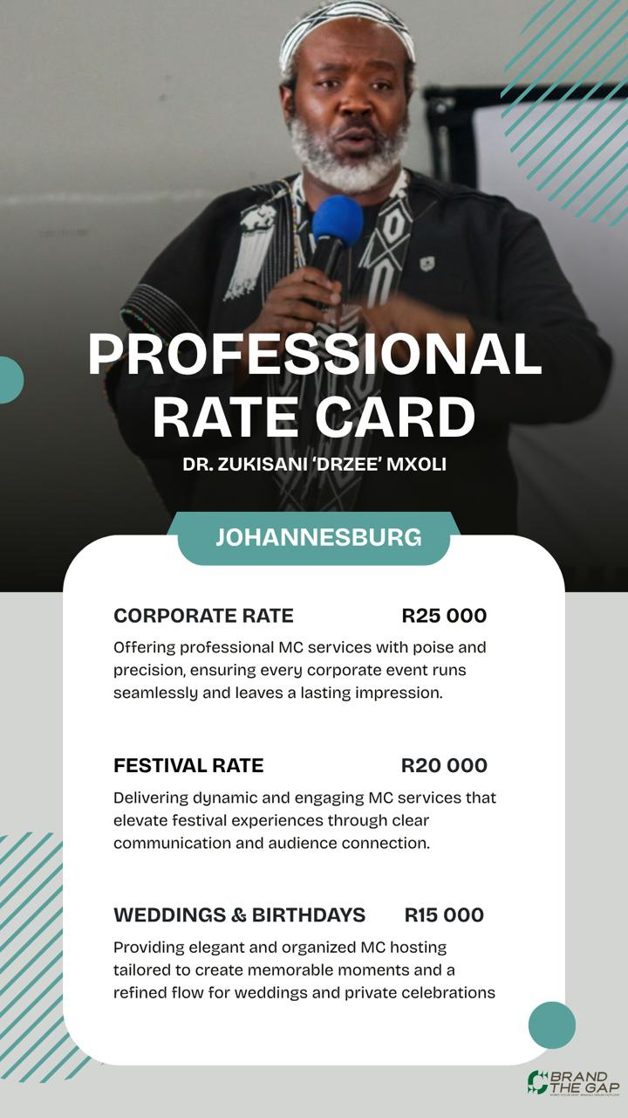

7. Past Speaking Experience & Notable Platforms
Better Me Men's Conference; Recharge Your Marriage Conference; SAPS International Men's Day; Entrepreneurs Awards; School Leadership & Anniversary Celebrations; Year-End Business Seminars; IMBIZO by DrZee Leadership Initiatives.
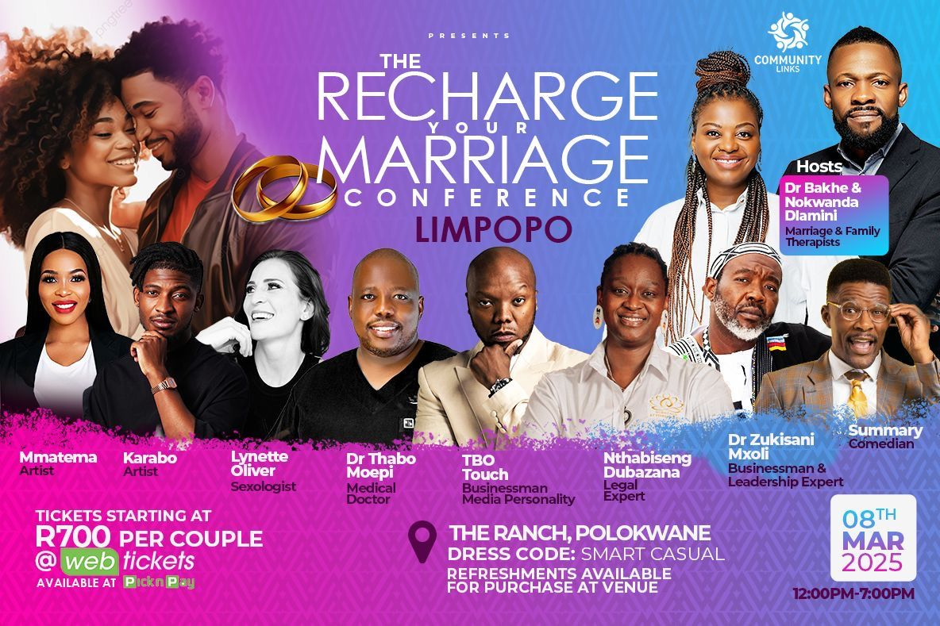
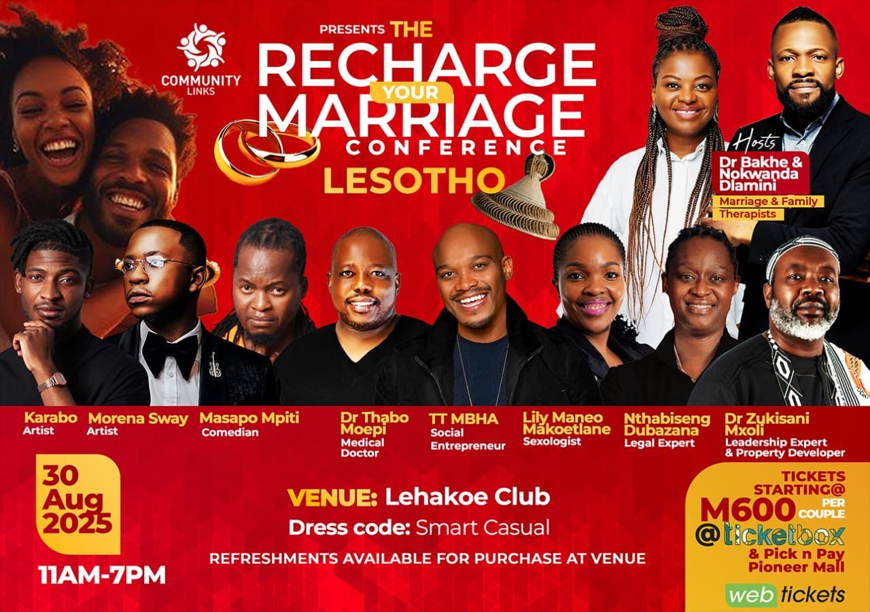
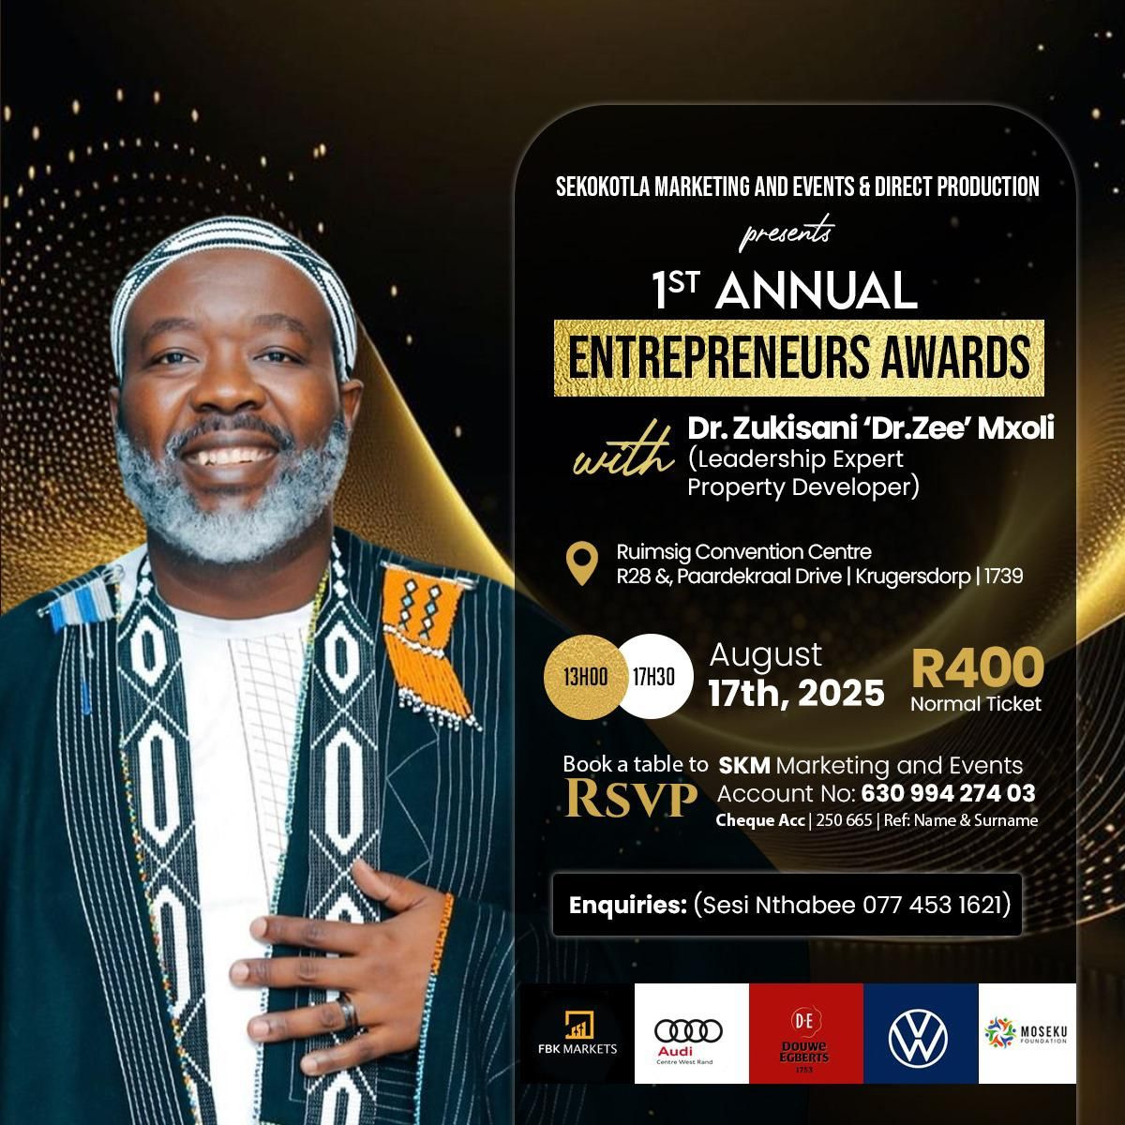
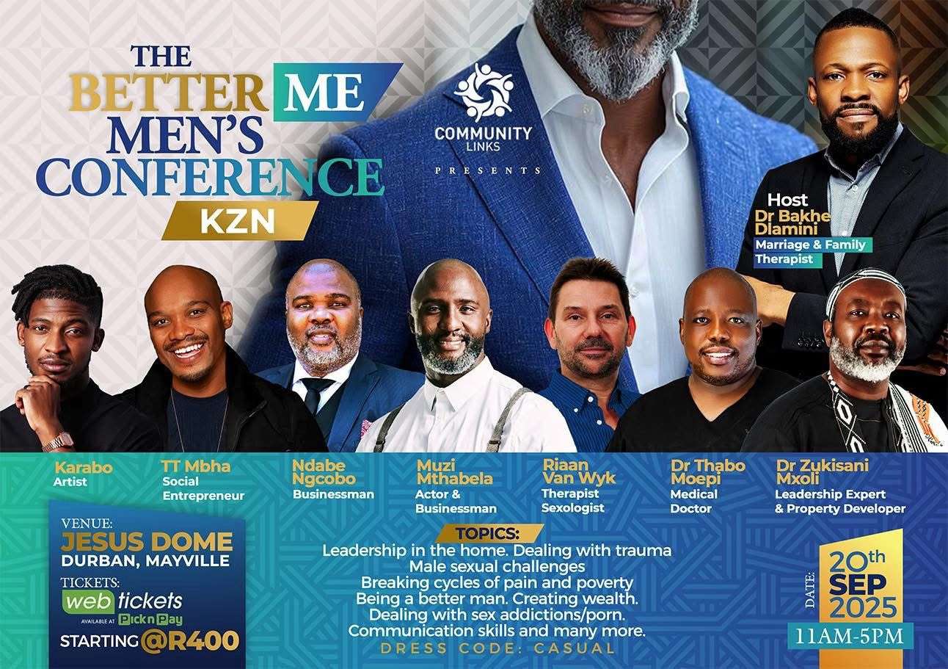
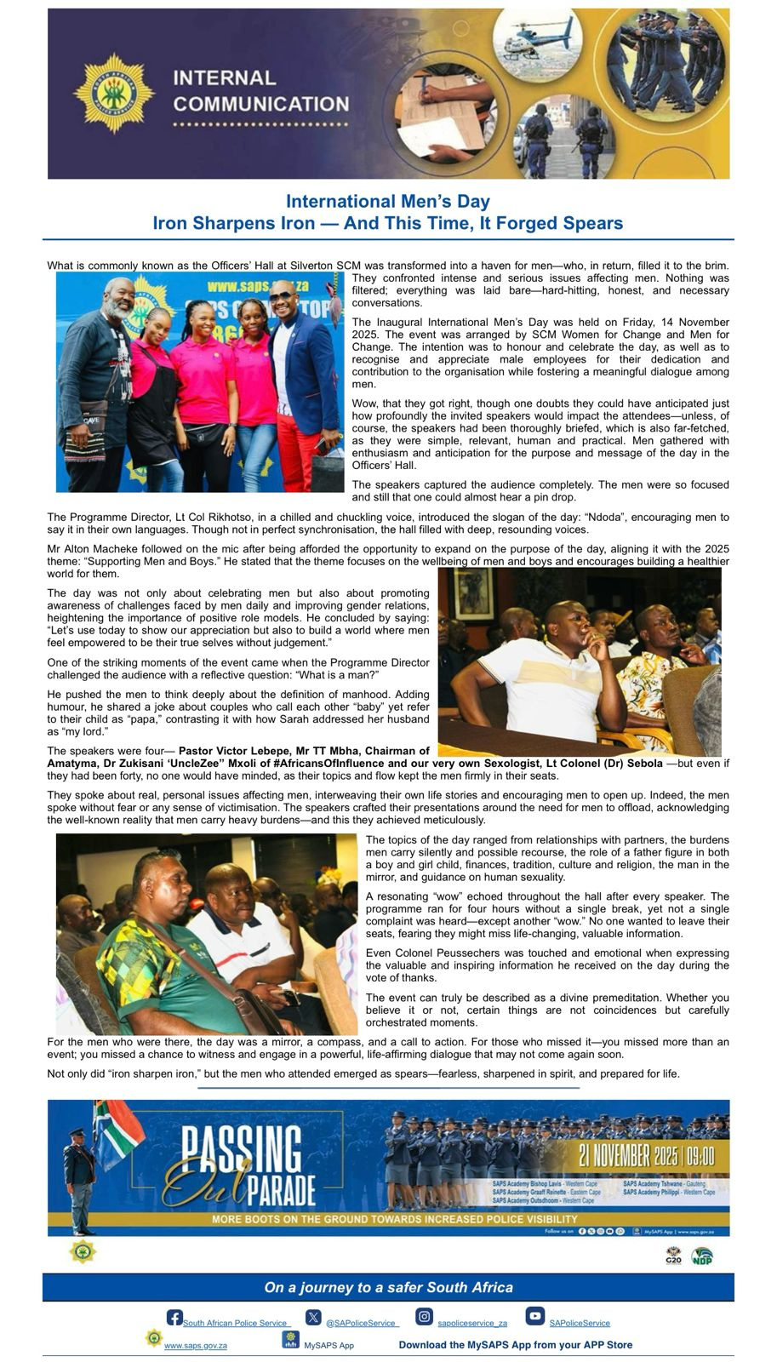
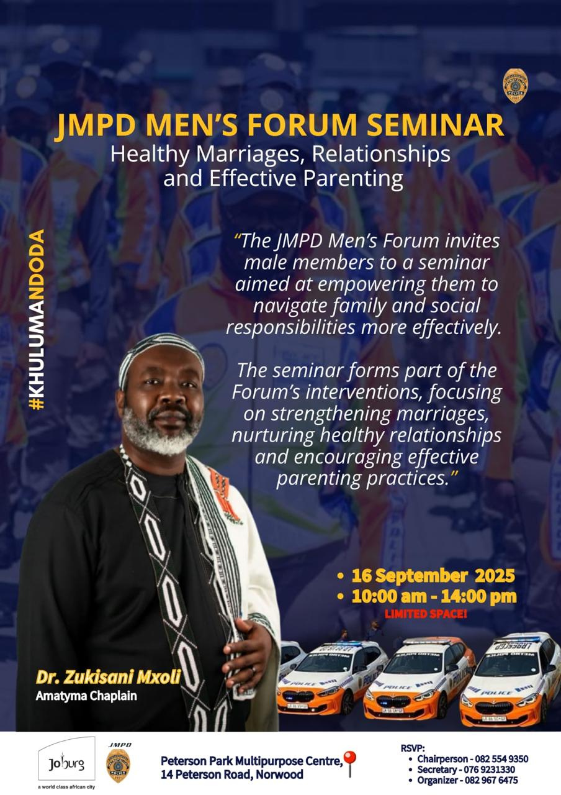
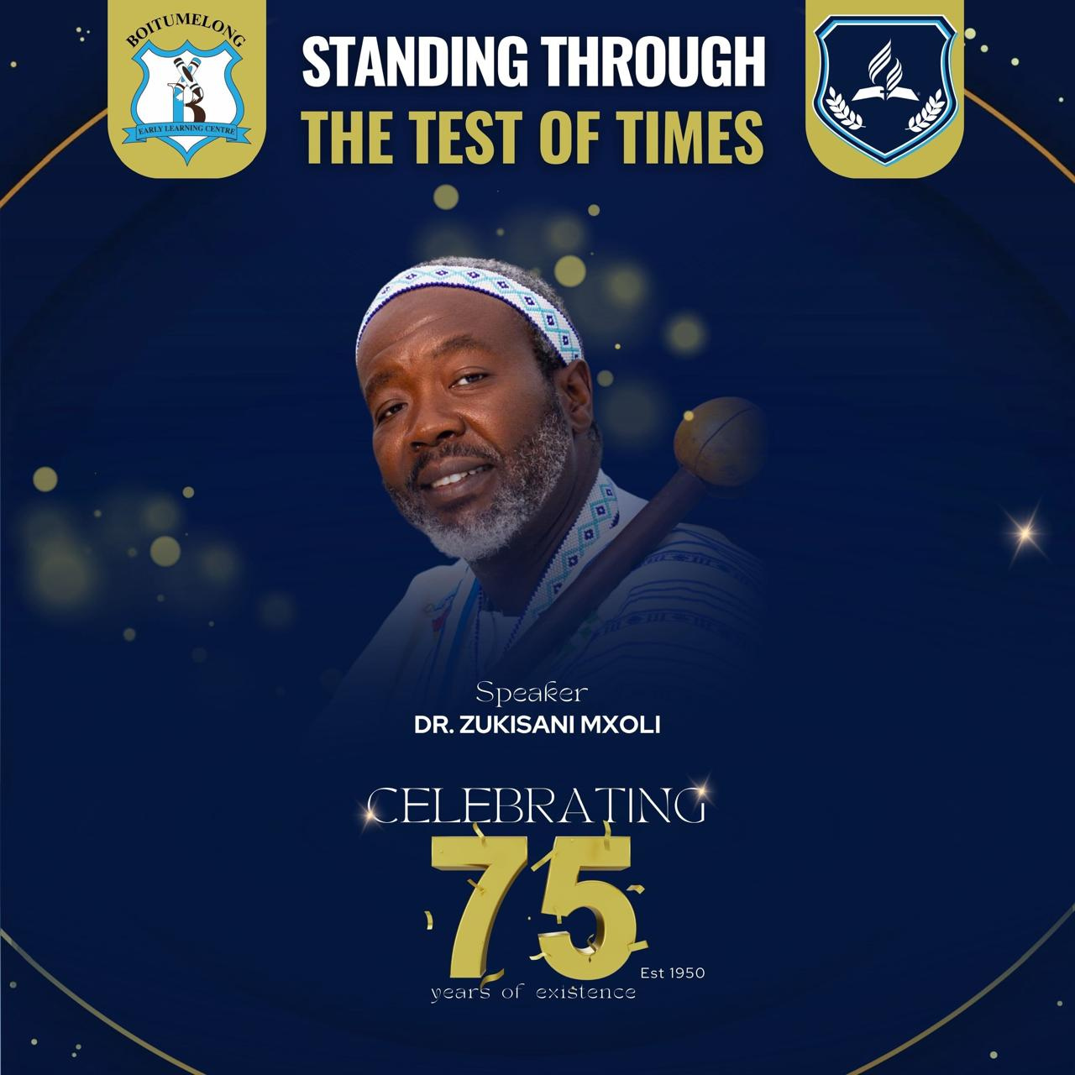
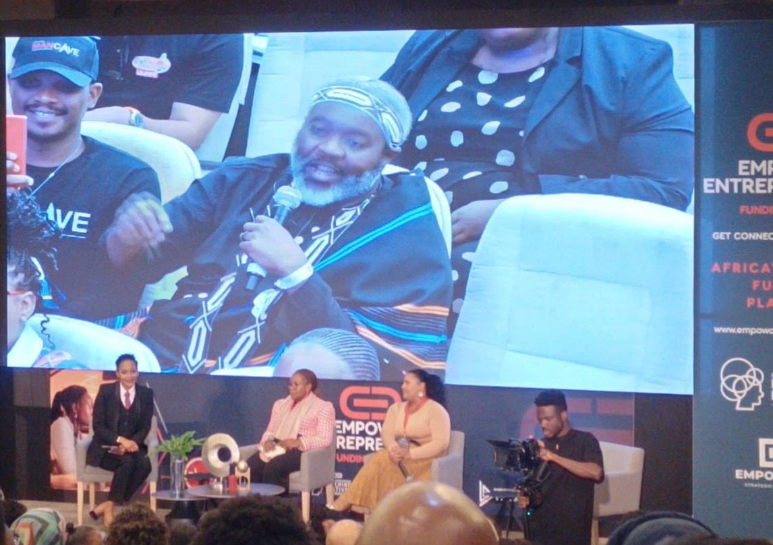
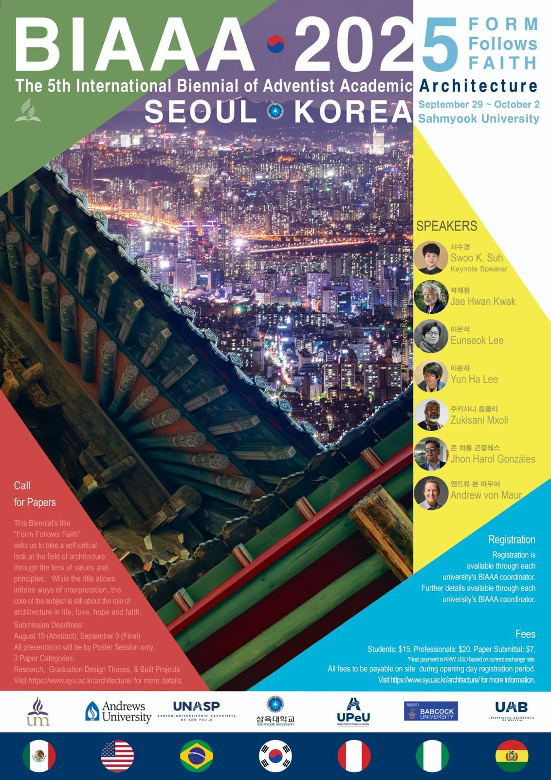
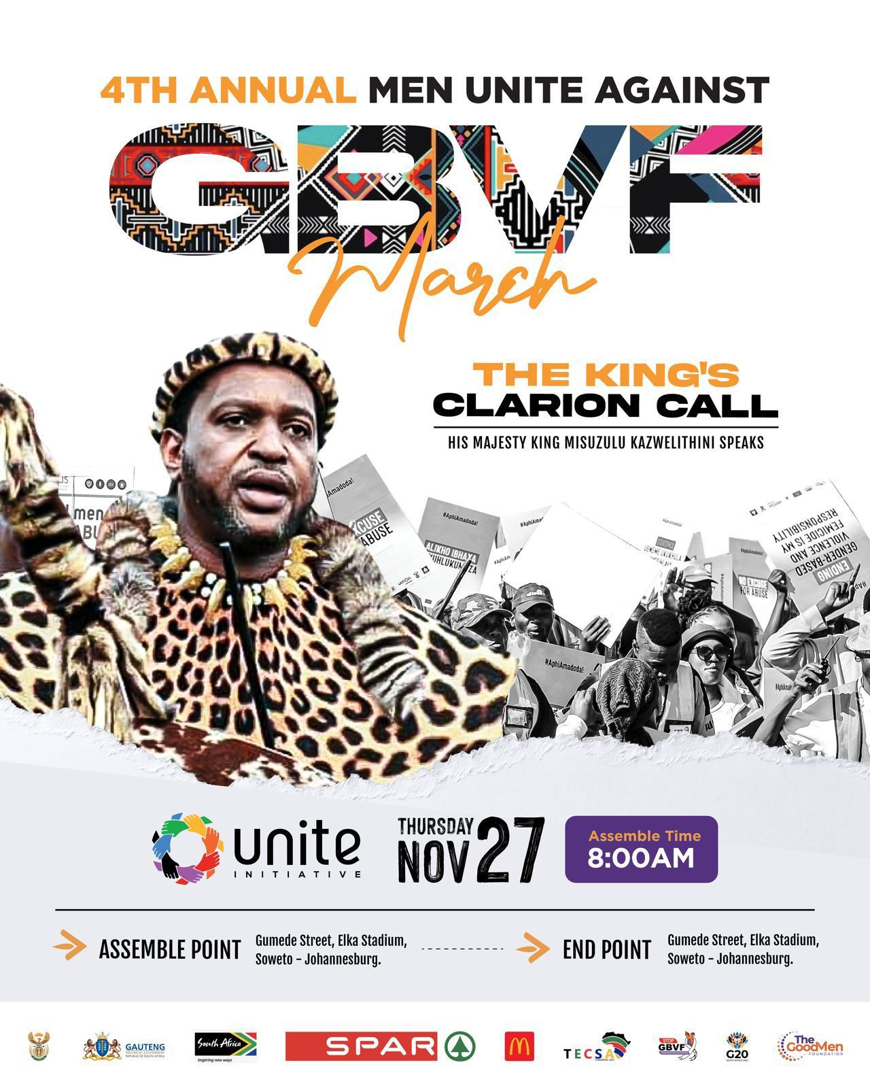
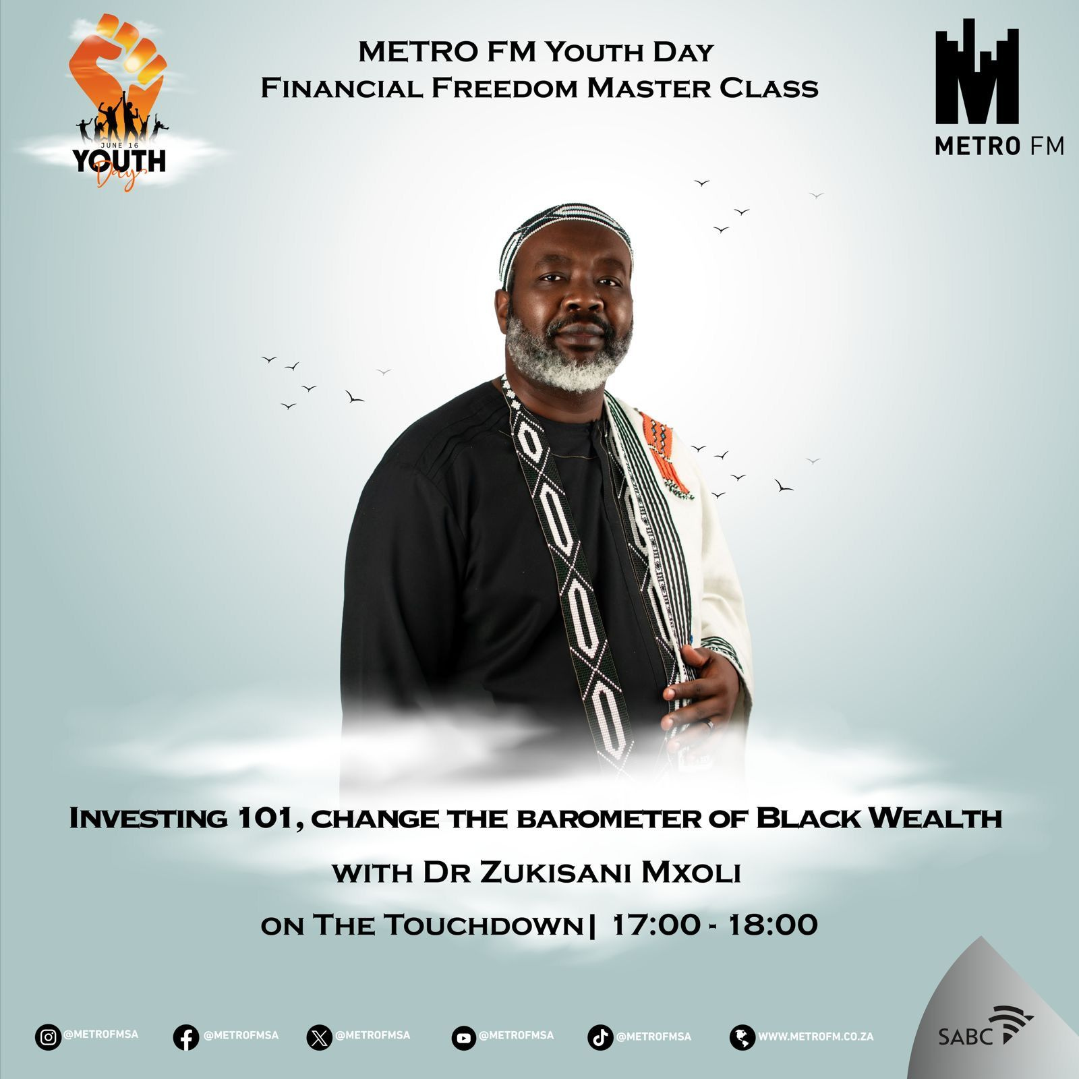
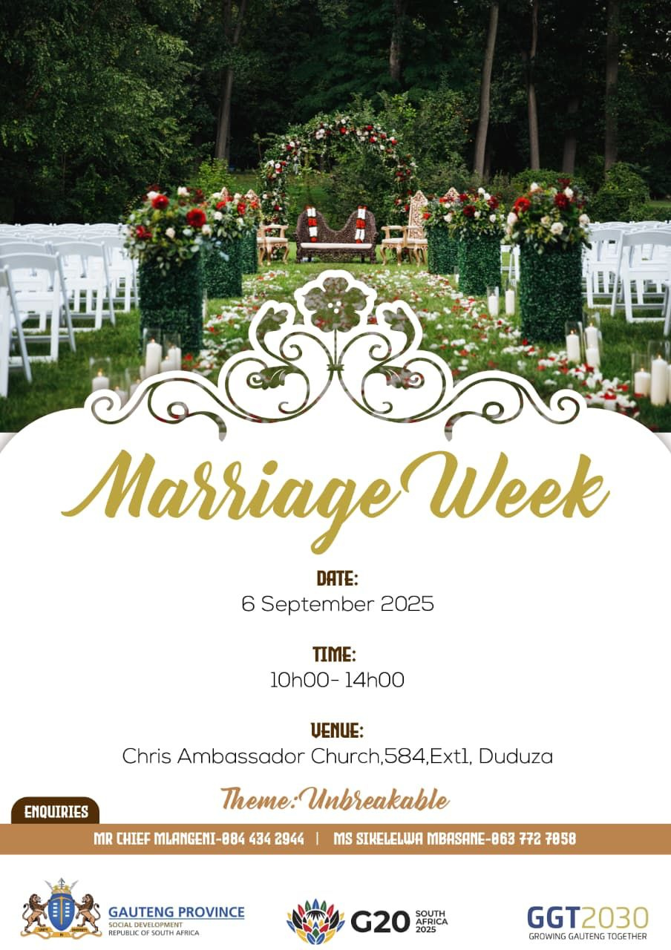

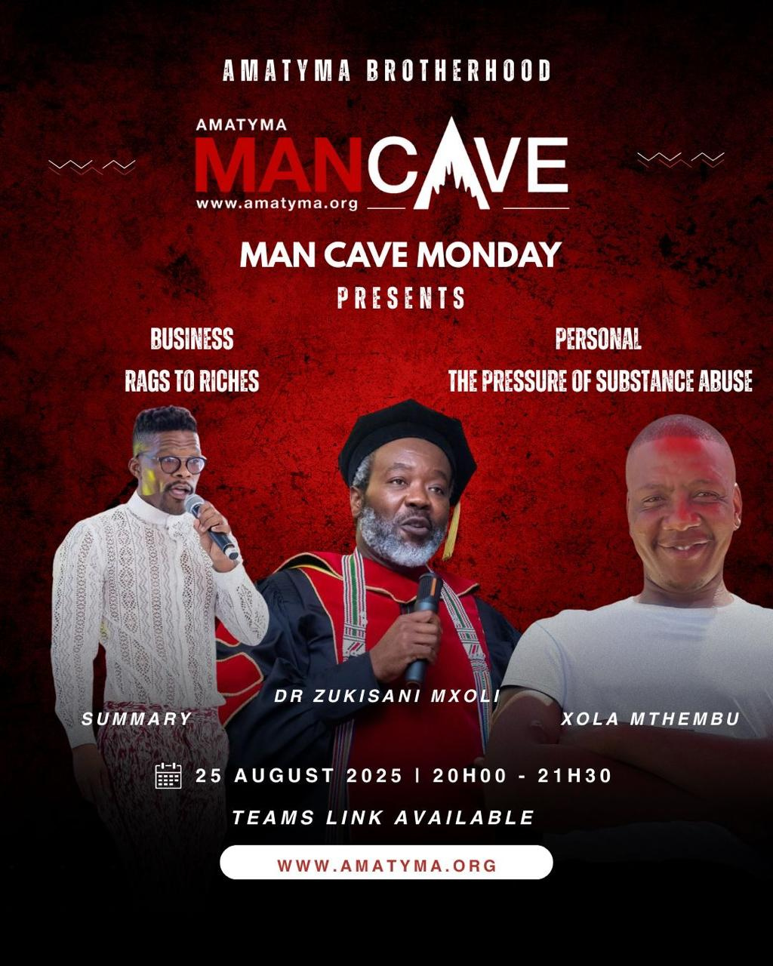
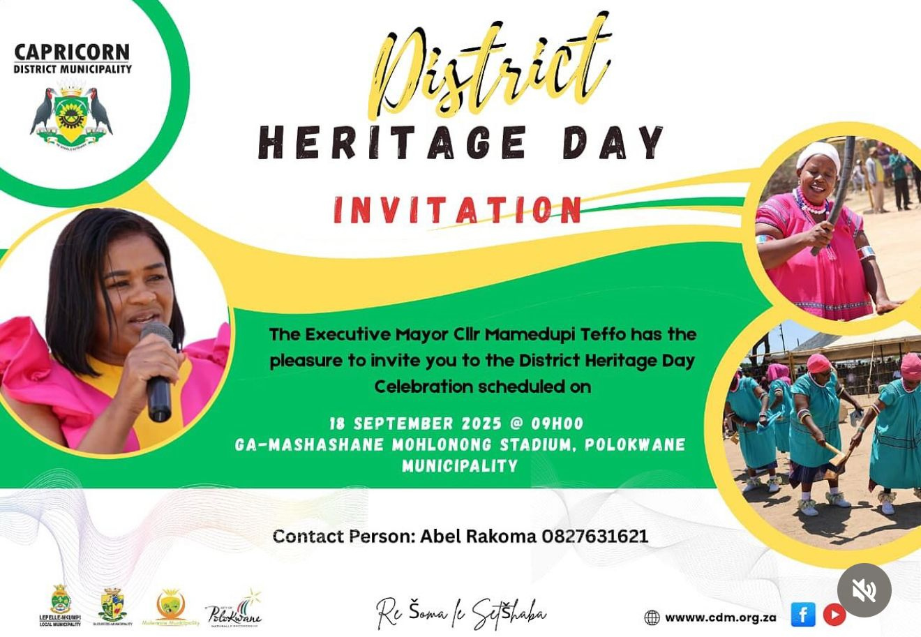
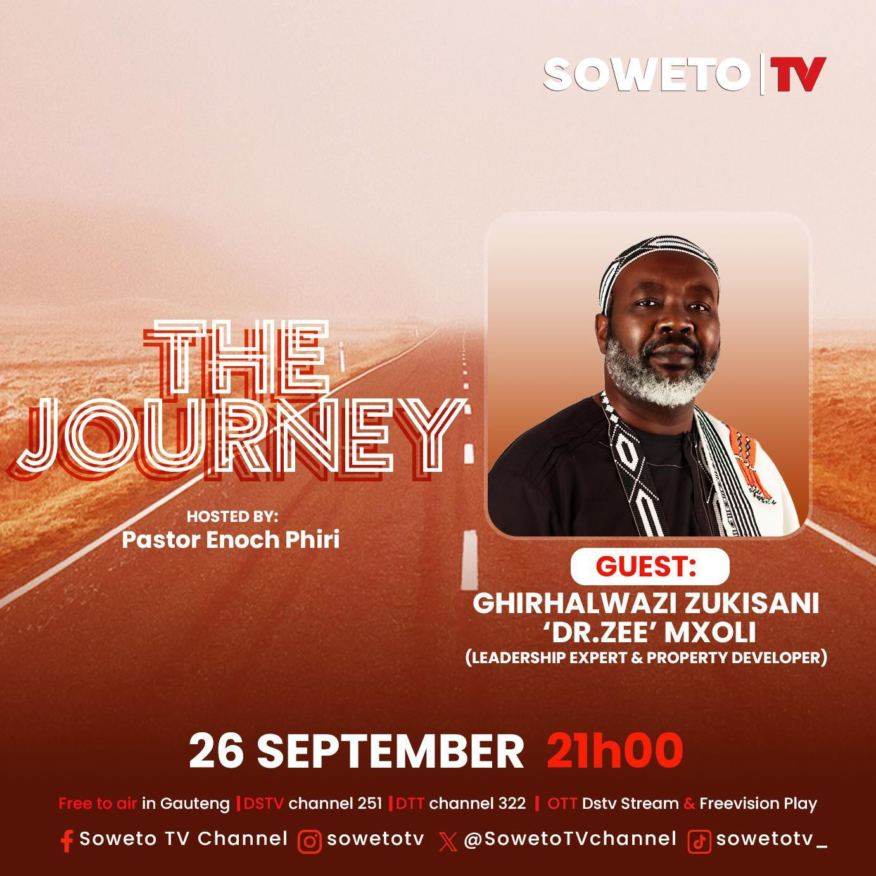
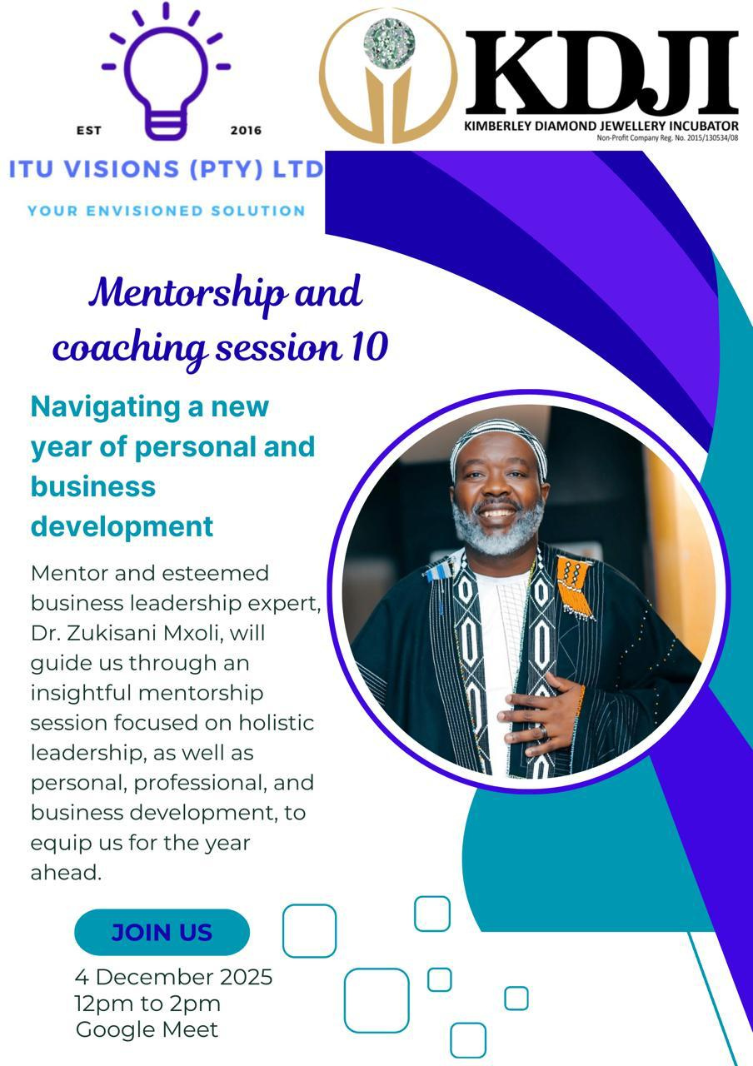
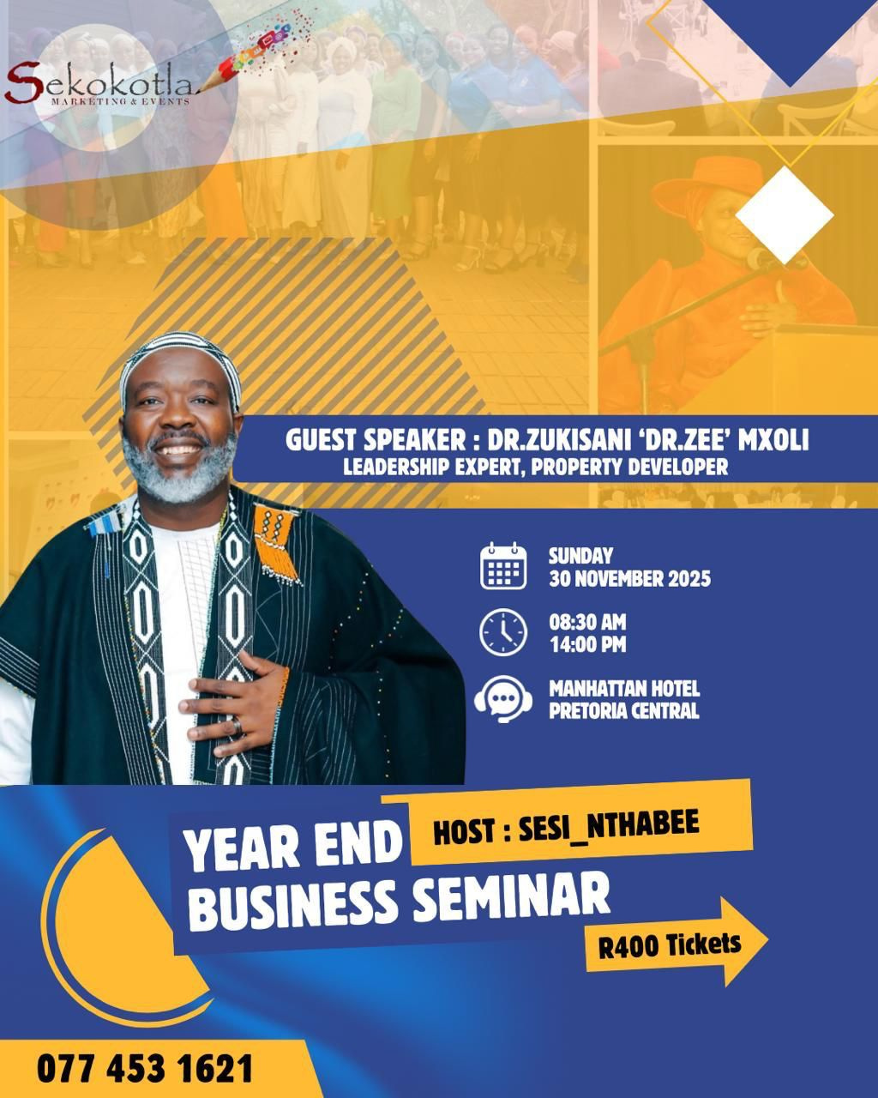

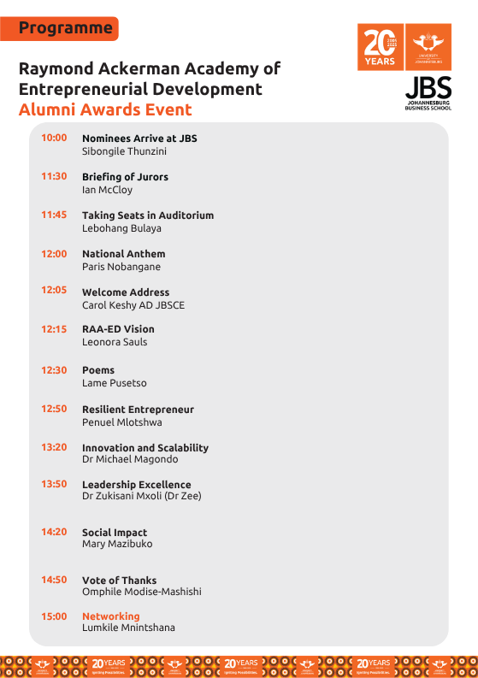
8. Video Clips / Showreel
Speaking highlights and videos are available on Dr. Zee's official social media platforms.
9. 9. Testimonials or references, where available
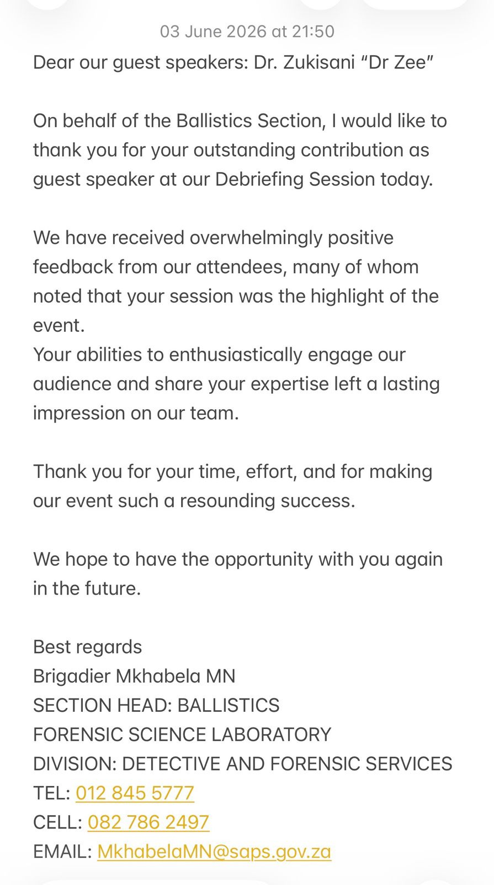
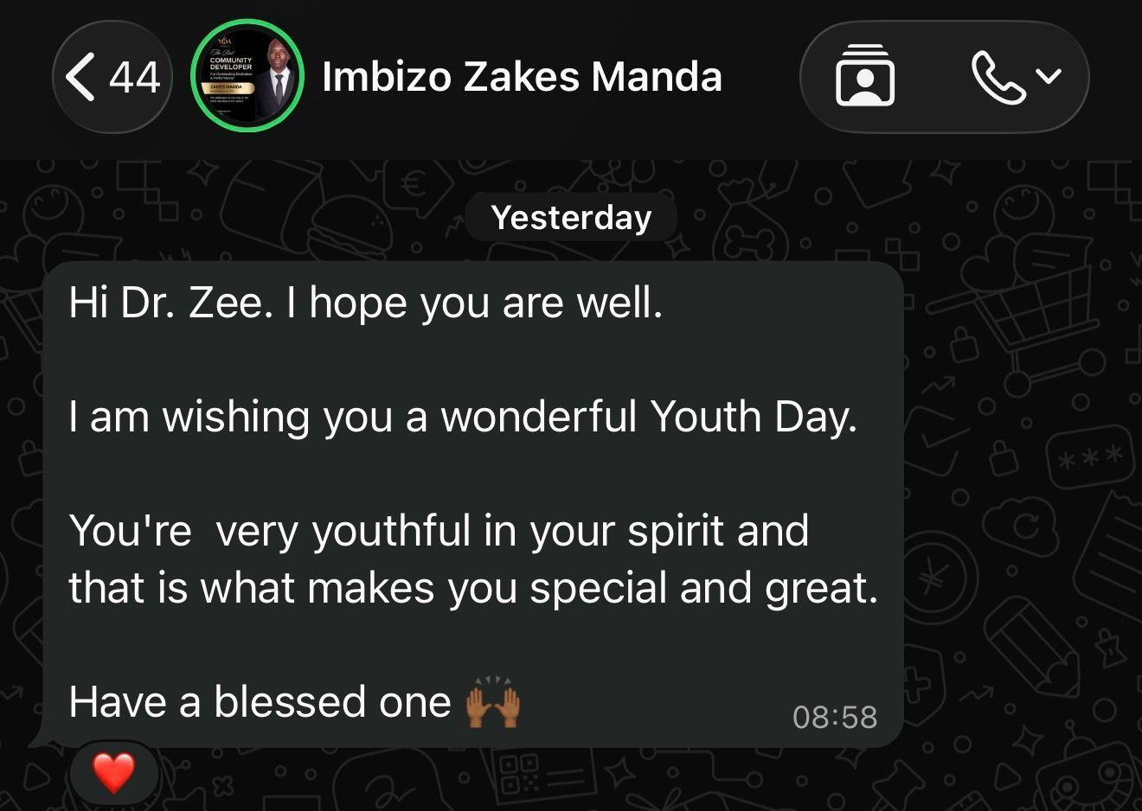

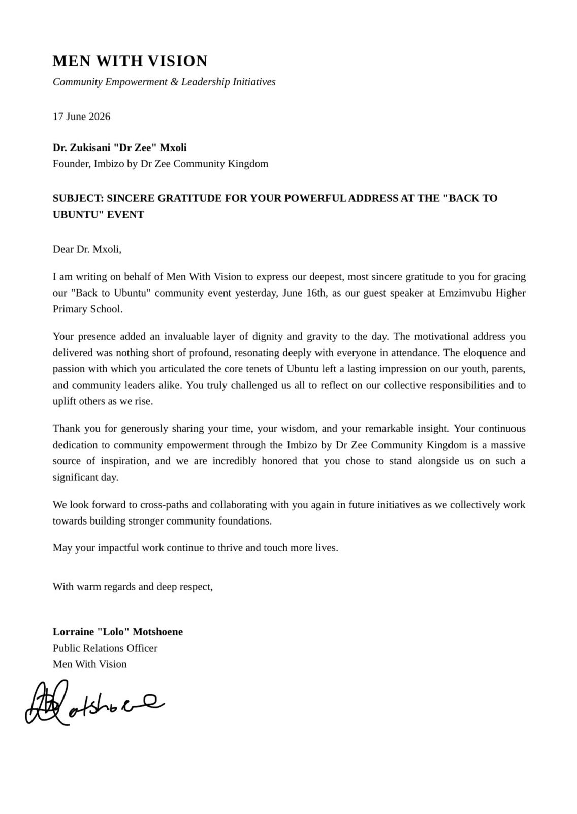
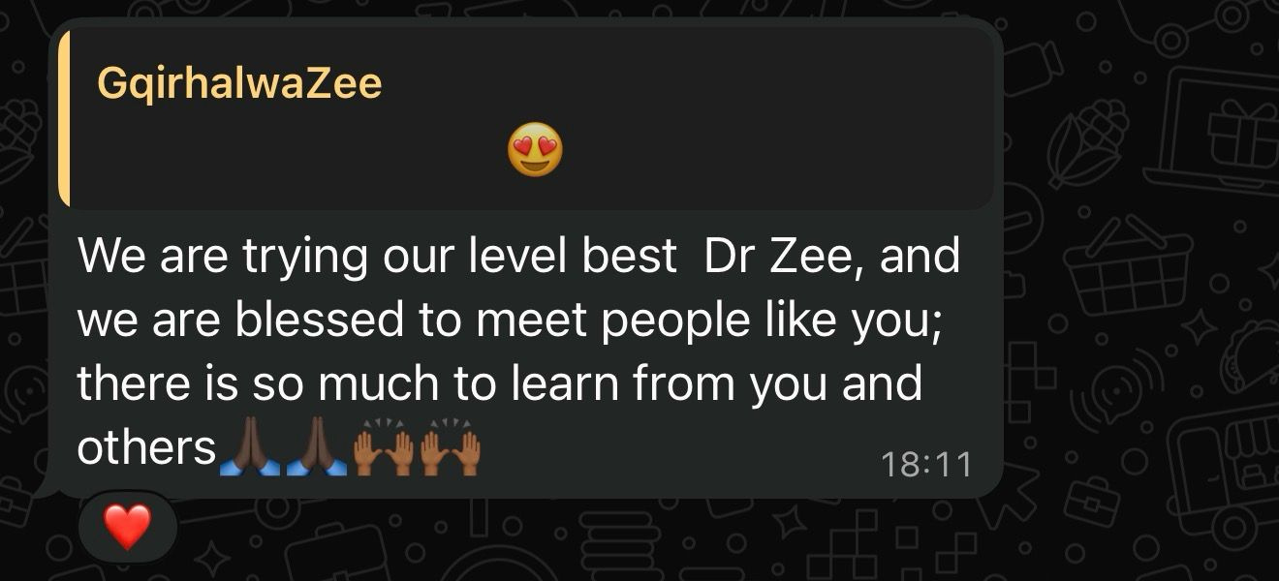
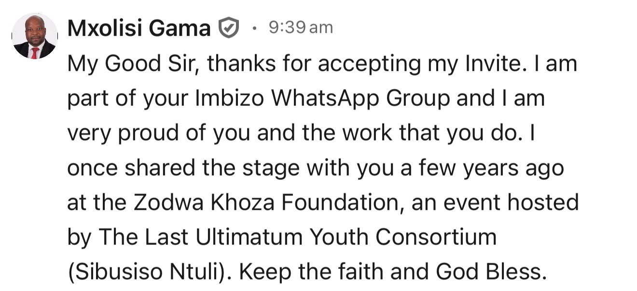
A Heartfelt Thank You to Dr Zee 🙏🏽

On behalf of Bethesda Men's Clinic and Trauma Centre and Mashudu Priscilla Neluheni, we would like to extend our sincere appreciation and gratitude to Dr Zee for honouring our invitation and delivering such a powerful and educational presentation on Men's Mental Health, Wellness, and Well-being.

Your insightful message, wealth of knowledge, and passion for improving men's mental health made a significant contribution to the success of our book launch and the official opening of Bethesda Men's Clinic and Trauma Centre. Your presentation was inspiring, thought-provoking, and left a lasting impact on everyone in attendance.

We would also like to express our heartfelt thanks to your beautiful wife for accompanying you and for her support. Her presence added warmth and encouragement to this special occasion.

Thank you for your invaluable contribution, your commitment to community development, and your dedication to promoting mental health and well-being. We truly value your partnership and look forward to working together on many more impactful programmes and initiatives in the future.

May God continue to bless you both as you touch and transform lives.

With sincere appreciation,

Mashudu Priscilla Neluheni
Founder, Bethesda Men's Clinic and Trauma Centre

Palesa Mboweni
Public Relations and Stakeholder Relations Coordinator
10. Social Media & Website
Website: www.mxoliproperties.com
Facebook:https://www.facebook.com/share/1CW2wAgacu/?mibextid=wwXIfr
Instagram :https://www.instagram.com/imbizobydrzee
& TikTok: @DrZee101https://www.tiktok.com/@imbizobydrzee?_r=1&_t=ZS-97TmizWZV9U
LinkedIn: https://www.linkedin.com/in/imbizo-by-dr-zee-mxoli-91208719?utm_source=share_via&utm_content=profile&utm_medium=member_ios
11. Academic and professional credentials summary
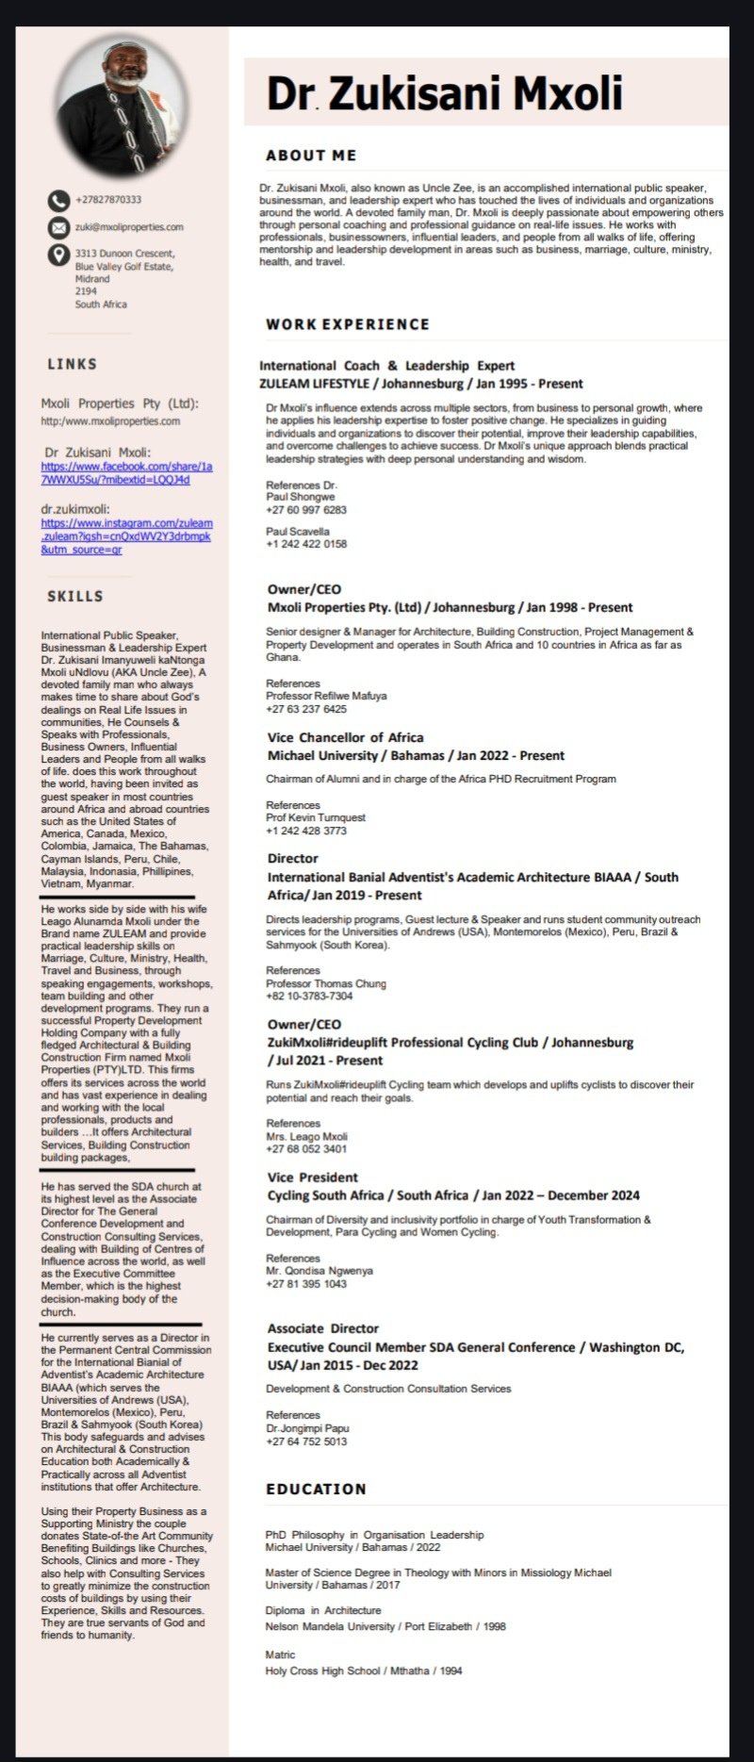

12. Company Registration & Tax Documentation
Company registration documents and tax clearance documentation are attached separately.
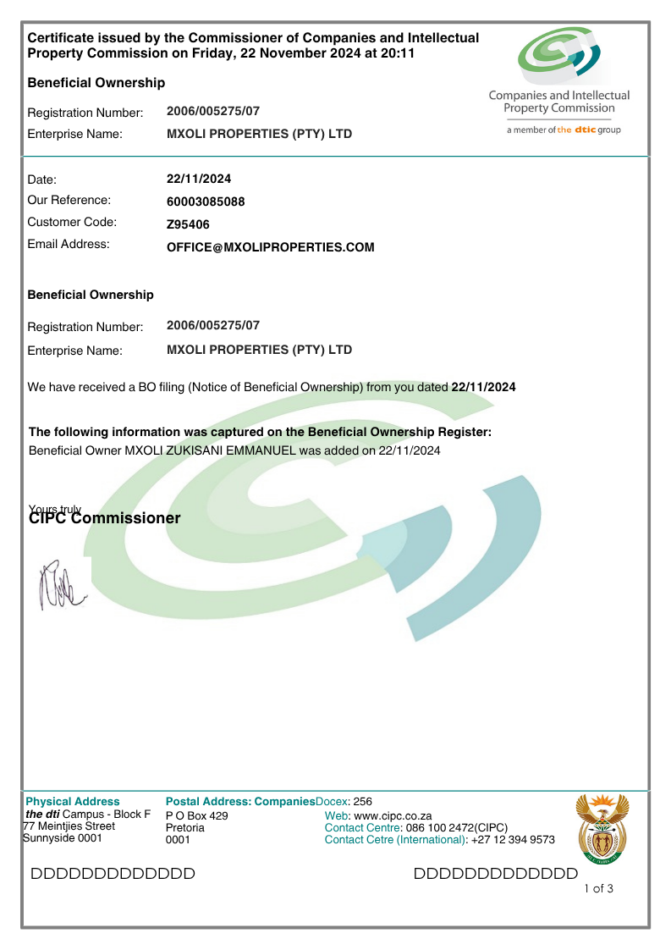
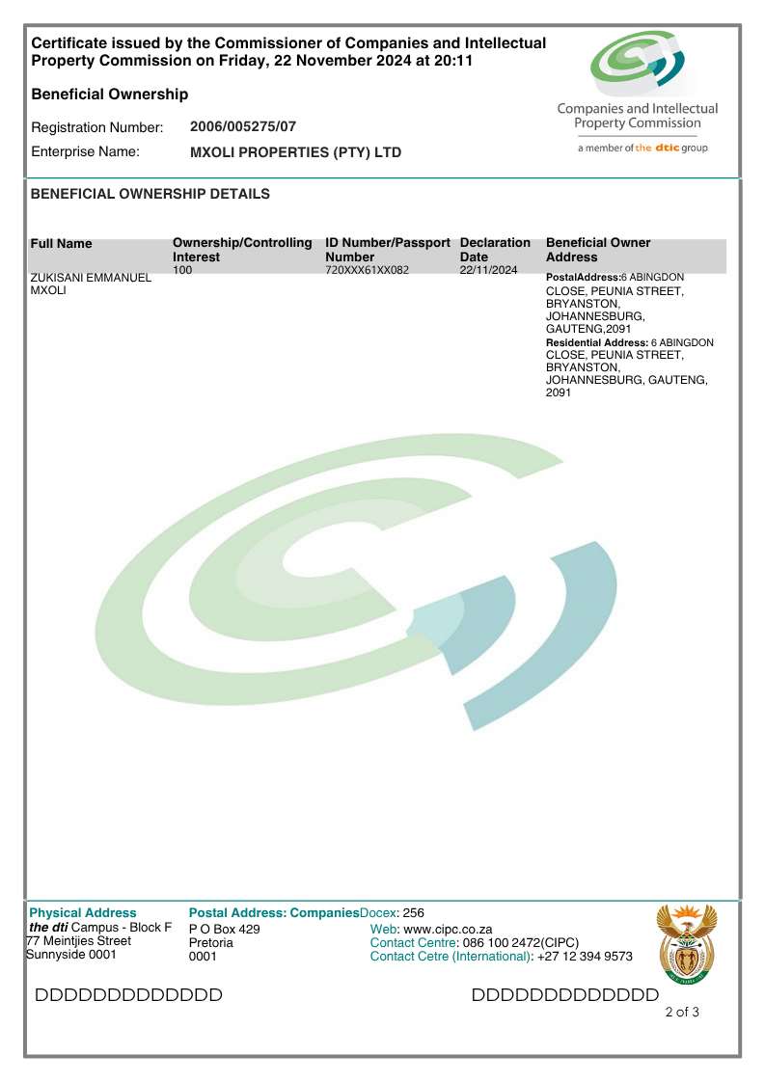
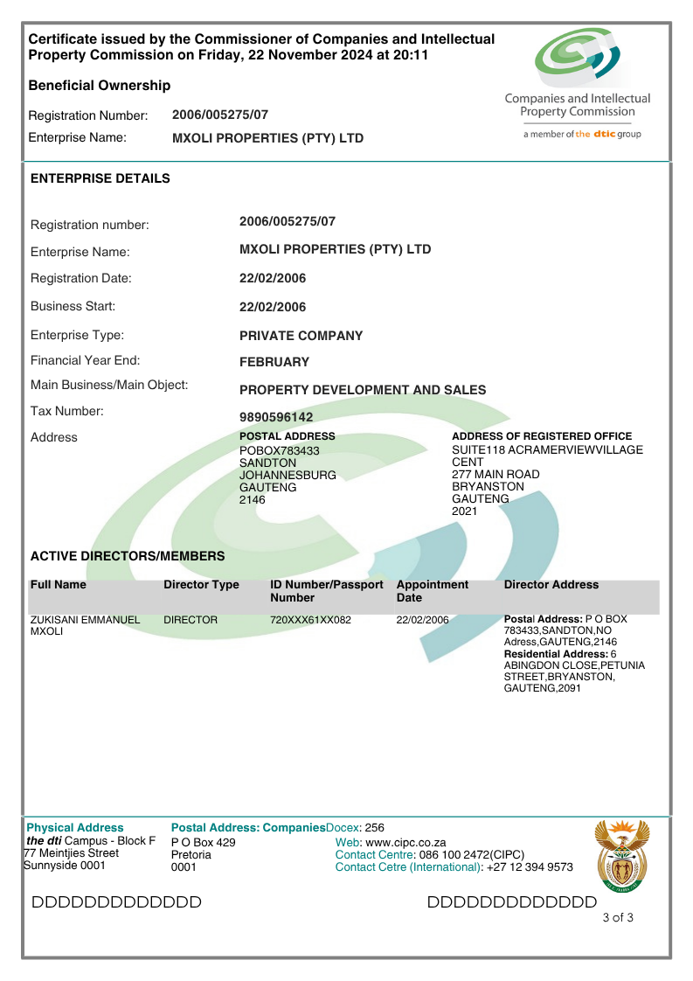
13. Banking Details / Invoice Information

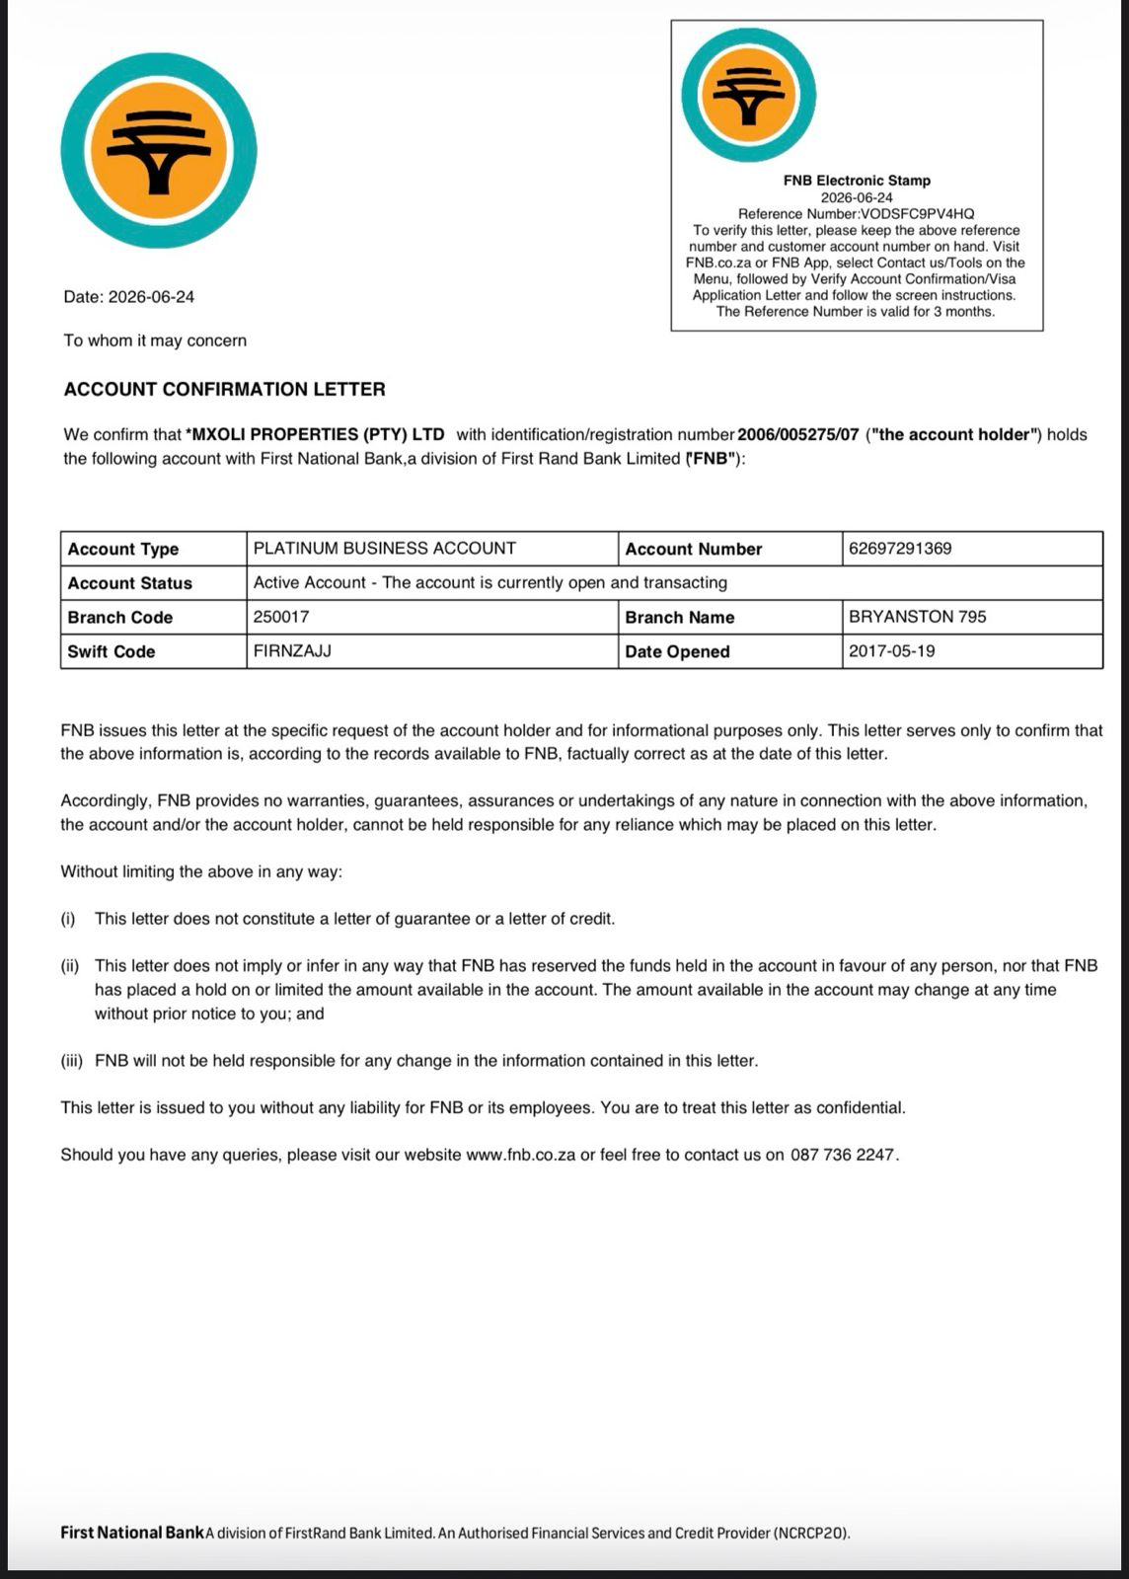
14. IMBIZO by DrZee
Comprehensive information on IMBIZO by DrZee, including the concept note, seven-pillar framework, membership information, growth strategy and partnership opportunities, has been included in the accompanying attachments.
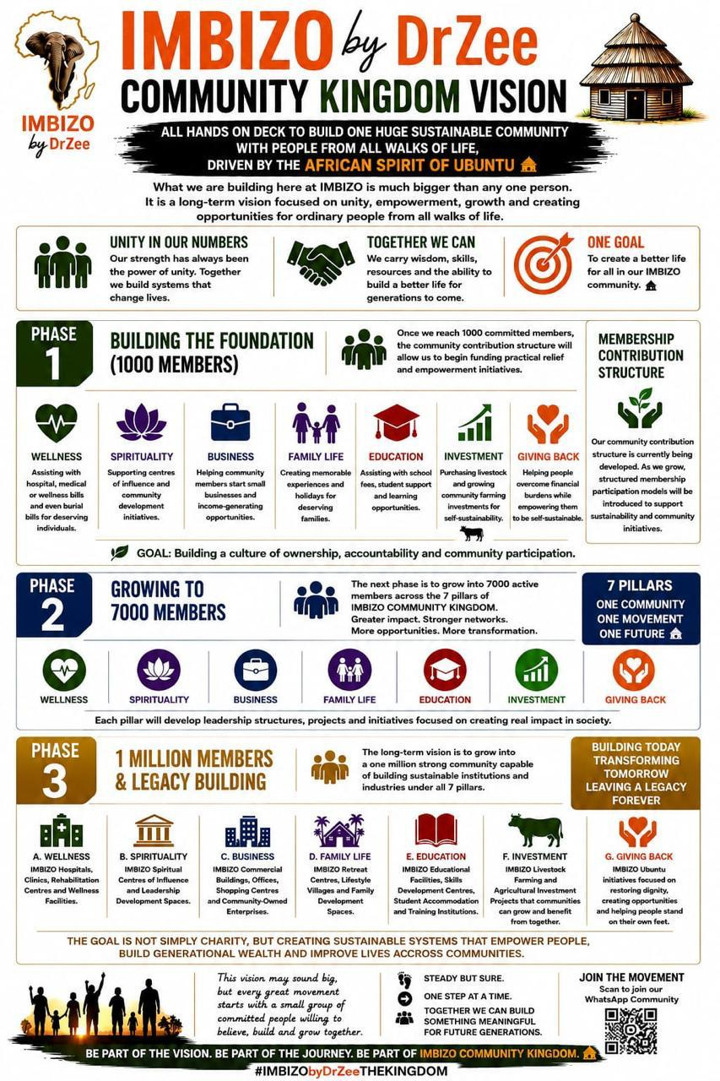

Here below is my response to the last point
no 15 Any material on Imbizo by Dr Zee, including concept note, pillar breakdown, current membership stats, growth targets, and partnership opportunities

Please allow me to share the practical ways and business models we are doing the 7 Pillars of IMBIZO and we can explore which ones we can collaborate on if not all

1. WELLNESS PILLAR
We do Occupational Health and we give a commision for any referrals for companies needing Medical Certificates like Construction Sector, Mining Sector, Trucking Sector, Warehouses and more …
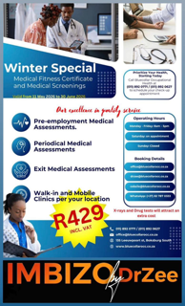
2. SPIRITUALITY PILLAR
DrZee BIO: IMBIZO by DrZee Community Celebrity King • International Public Speaker • Businessman • Moral Regeneration and Leadership Expert A devoted family man who makes time to Counsel, Coach & Address Professionals, Business Owners, Influential Leaders, Institutions & Communities, on Real Life Issues affecting Men, Women, Youth, Families and People from all walks of life; equipping them with leadership skills.
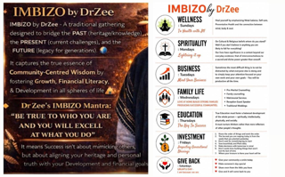

3. BUSINESS PILLAR
We do Architecture, Building Construction, Project Management and Full Property Development, more on the poster 🏗️
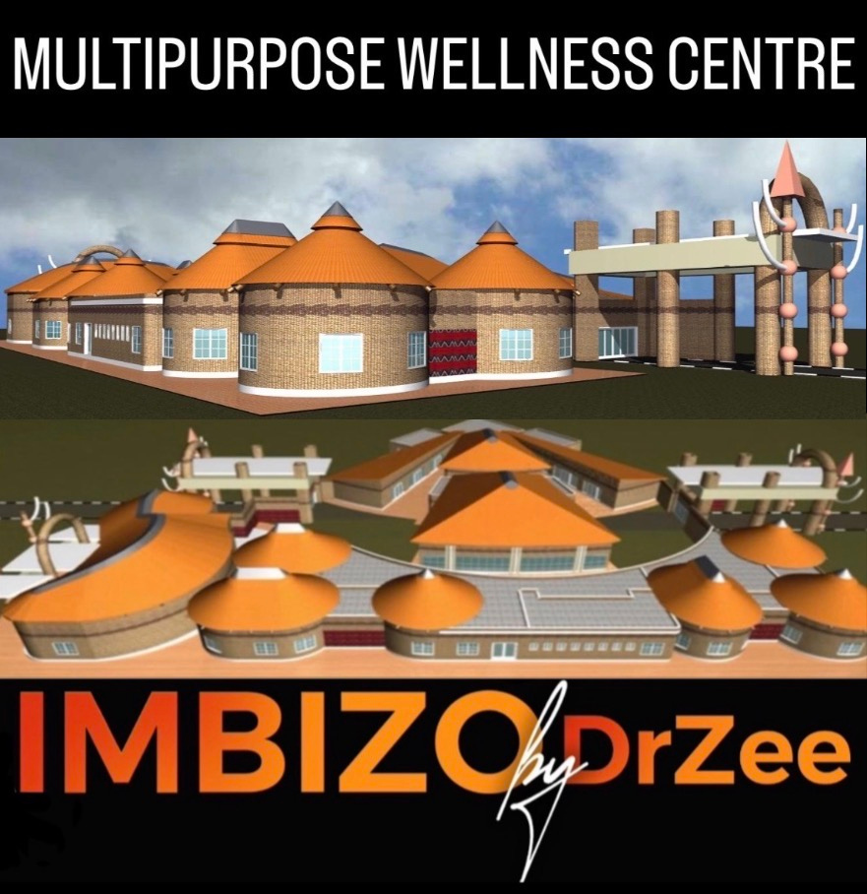

4. FAMILY LIFE PILLAR 💍
We do Marriage enrichment programs, Counselling at any stage of a family structure and Speaking over and above officiating at weddings, talk to us for bookings #HalaHala😀
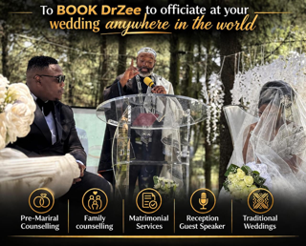

5. EDUCATION PILLAR 📚
It’s never too late to start your next level of Education and you never stop learning 📚
I started my Doctoral Studies in 2019 and Graduated November 2022 💪🏾
This Long Distance Learning Program is still available for those who would like to further their studies 🎓(Get in touch with us)
Apart from Building and donating at Helderberg College of Higher Learning, We also built and donated the Dr. R.N. Mxoli Centre of Influence in Flagstaff Eastern Cape, dedicated to my late father Dr.R.N. and the local community is now running a successful Preschool there preparing future leaders 🙌🏾 Together We Can Achieve More

IMBIZObyDrZee Education Nuggets👌🏾
1. True Education must impart more than academic knowledge…
2.True Education must foster a balanced development of the whole person—spiritually, intellectually, physically, and socially…
3. AN EDUCATED AFRICAN SHOULD BE THE BEST VERSION OF AN AFRICAN, well EQUIPPED to bridge the PAST (heritage & knowledge), the PRESENT(current challenges), and the FUTURE (legacy for generations).
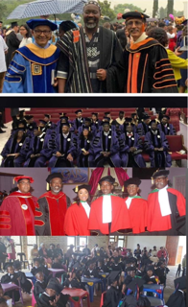

6. INVESTMENT PILLAR 📈
IMBIZO LIVESTOCK FARMING🐄
We are doing it the African way by going BACK TO THE FUTURE 🔥 Join “Touch The Farmer” and have YOUR OWN CATTLE in OUR FARM here in GAUTENG and enjoy the experience of visiting and seeing your own cattle GROW, PRODUCE MILK anytime you like WITHOUT THE STRESS OF THE FARM, FEEDING & SHERPHERED; we take care of that🛖 Anyone can start from as little as R1000 A MONTH to build towards owning your 1st cow and your OWN HERD and offcourse you can also start big like ‘Touch the Farmer’ with your own BULL & 4 Heifers [Heifers are female bovines (cattle) that have not yet produced a calf - very crucial for herd breeding and milk production] 🐄🐄🐄🐄 Remember once the cow is yours IT IS YOURS and any calf it produces each year IS YOURS, you just see your INVESTMENT GROW while we run the farm for you and you can decide to slaughter or sell your own cattle and cash in on your own investments any time 🕰️ We are starting IN OUR FARM here in GAUTENG and expand 👌🏾
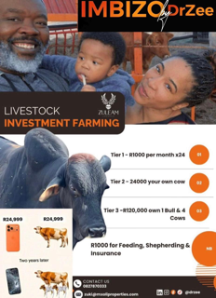

7. UBUNTU GIVE BACK PILLAR🛖
We continue to share our IMBIZO VISION with you on this day because IMBIZO is about implementing the change we want to see in COMMUNITY DEVELOPMENT by using our natural SPIRIT of UBUNTU 🌍
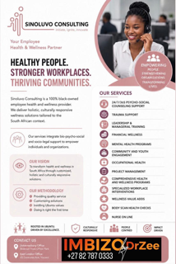

In our VISION, which is our WORKING DOCUMENT 👌🏾 we have outlined a clear sense of PURPOSE and DIRECTION; We are FOCUSED & COMMITTED to reach our GOAL of DEVELOPING A SOCIAL & ECONOMIC SUSTAINABLE SOCIETY that will be built by the PEOPLE, for the PEOPLE🙏🏾

We encourage you to READ our IMBIZObyDrZee VISION, INTERNALISE it and OWN it so that and come JUNE 30th 2026, we start PHASE 1 of the VISION together as one 🙌🏾

Between now and then we encourage everyone to invite one person to join our WhatsApp group and help our community grow with stable members because the more members we have the more IMBIZO Community Building work we will do 🦾

Don’t be on the sidelines, Be part of the Journey and invite your contacts - Let’s Grow Together 📈 https://chat.whatsapp.com/FXkRP8Cxm0k2zQ35AA6o5x?s=cl&p=i&mlu=0

God Bless
Dr. Zukisani Imanyuweli kaNtonga Mxoli uNdlovu (DrZee)
Moral Regeneration & Leadership Expert
ZULEAM#AfricansOfInfluence
Mobile: +27 82 787 0333
Socials: @DrZee101
Website: www.mxoliproperties.com

